**ONEs AND TWOs COMPLEMENT**  
**EXP NO: 17**

**AIM:**To compute one’s and two’s complement using 8085 processor.  
  
**ALGORITHM:**  
1)      Load the base address of the array in a register pair.  
2)      Move the data from memory location into accumulator.  
3)      Convert all ones into zeros and zeros into ones.  
4)      Add 01 to the accumulator content.  
5)      Store the results of one’s and two’s complement.  
  
**PROGRAM:**  
LDA 3000  
CMA  
STA 3001  
ADI 01  
STA 3002  
HLT  
  
**INPUT:**  
  
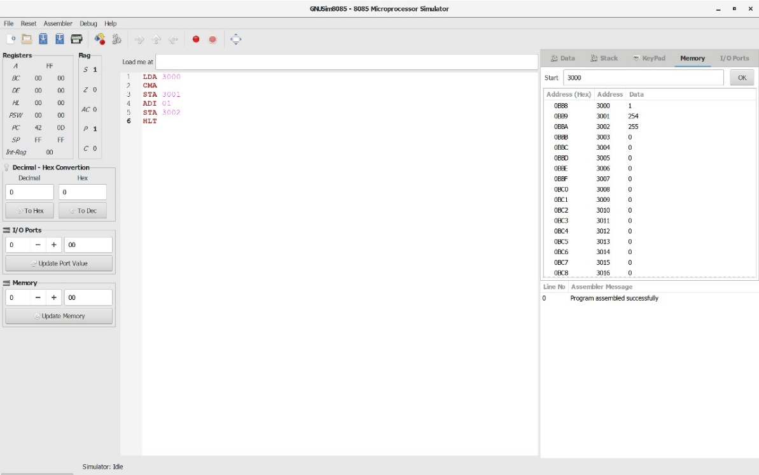  
   
  
  
  
  
  
  
  
  
**OUTPUT:**  
  
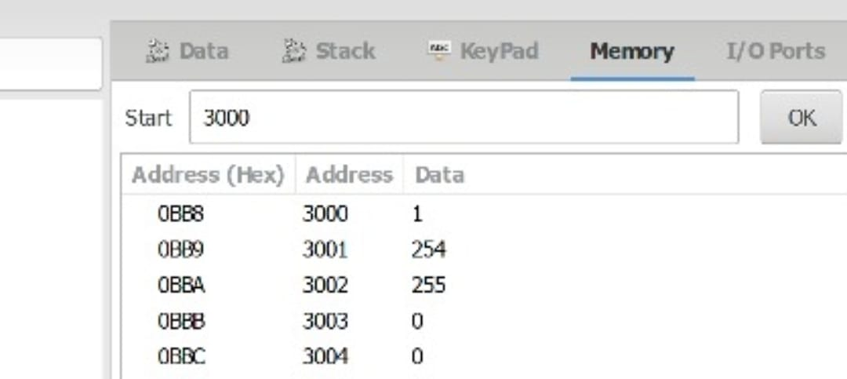  
  
  
  
   
  
  
   
  
  
   
  
  
   
  
  
  
  
  
  
  
  
  
  
  
  
  
  
**RESULT:**Thus the program was executed successfully using 8085 processor simulator.